**LEASE MANAGEMENT PROJECT**

**DOCUMENTION**

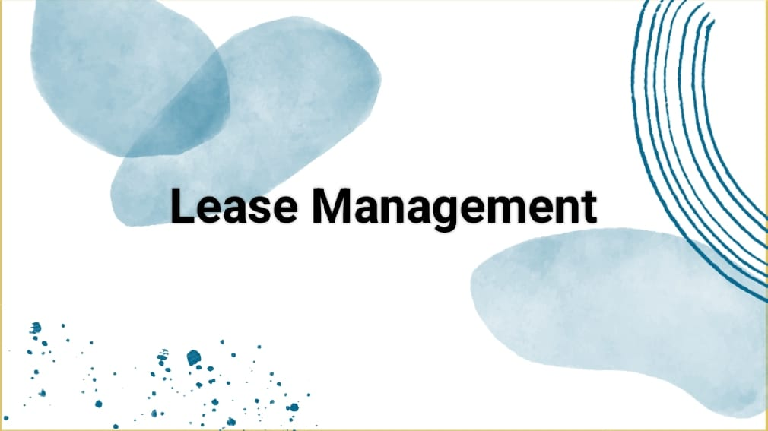

**College Name:** Cheran Arts And Scince College

**College Code:** BRU31

**TEAM ID:** MN2025TMID28326

**TEAM MEMBERS:**  4

**Team Leader Name**: Gomathi.D

**Email:** [gomugomathi385@gmail.com](mailto:gomugomathi385@gmail.com)

**Team Member 1:** Senduriya.R

**Email:** senduriya355@gmail.com

**Team Member 2:** Gayathri.S

**Email:** rsgayathri432@gmail.com

**Team Member 3:** Akalya.A

**Email :** [akalya474@gmail.com](mailto:akalya474@gmail.com)



**INTRODUCTION**

**Project Overview**:

Lease Management is a crucial business process for organizations that deal with rental or leasing of properties, vehicles, equipment, or other assets. Managing leases manually often leads to errors, missed deadlines, and lack of visibility. To overcome these challenges, Salesforce can be used as apowerful platform to design and automate a Lease Management System.

A Lease Management Project in Salesforce helps organizations streamline the entire lease lifecycle, from contract creation to renewal or termination. By leveraging Salesforce’s CRM capabilities, workflows, automation, and reporting tools, the system ensures better compliance, accurate billing, and improved customer relationships.

Salesforce Features & Configuration

**\*** **Custom Objects Created:**

> Property

> Tenant

> Payment

> Lease

>Each object includes necessary fields such as Start Date, End Date,

>Rent Amount, Status, etc.

Property:

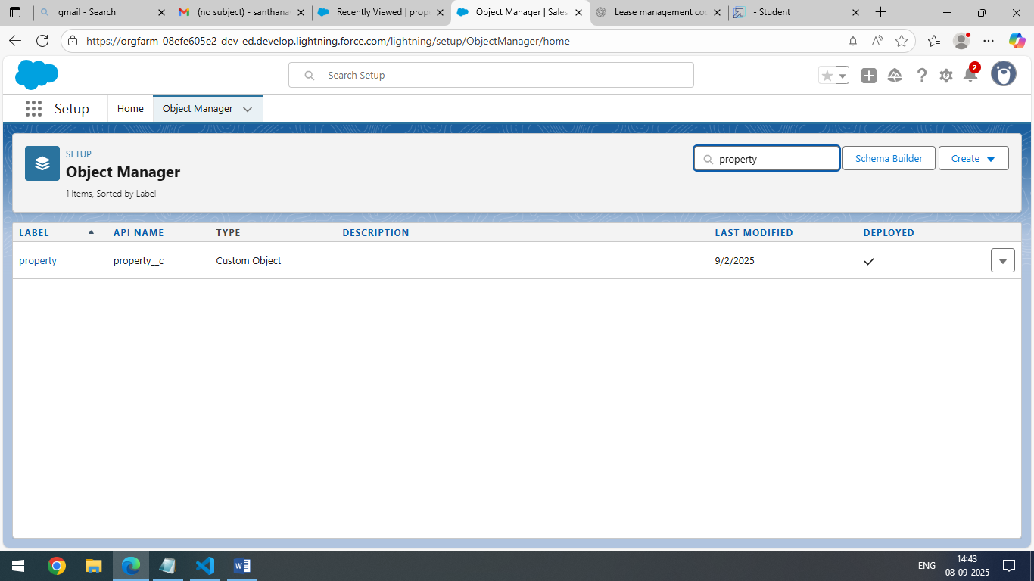

Tenant:

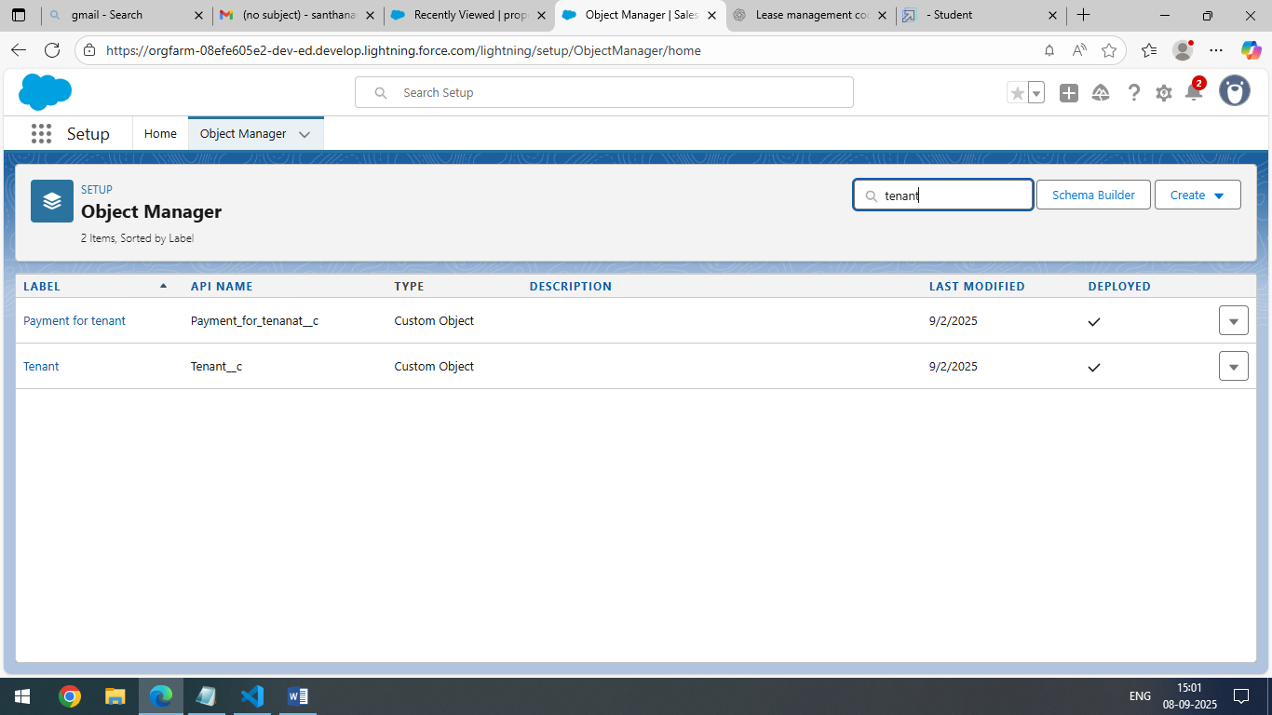

Payment:



Lease:

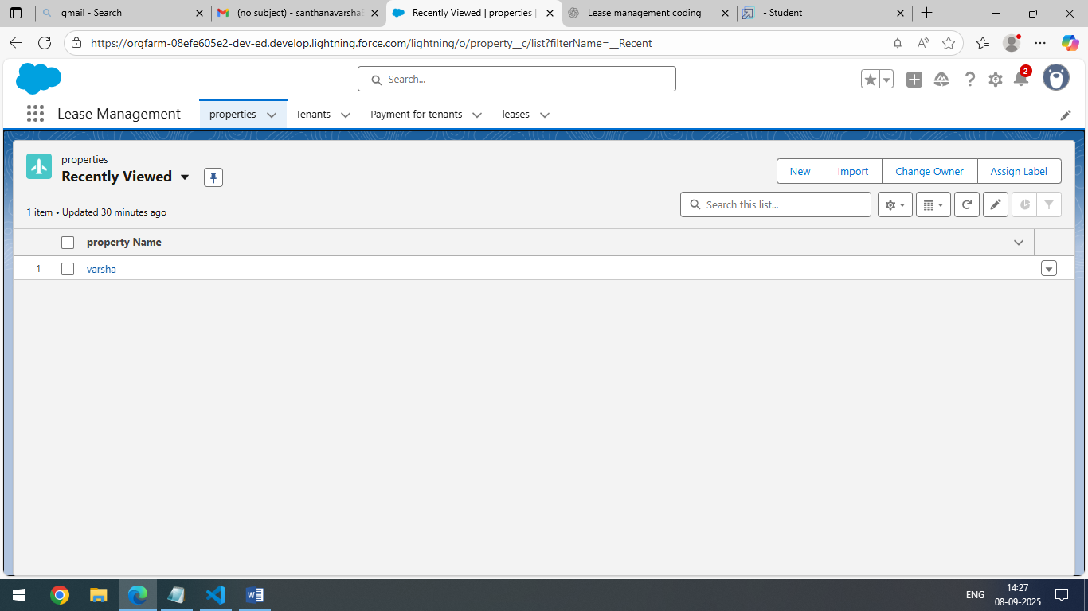

Tabs:

* To Create a Custom Tab.

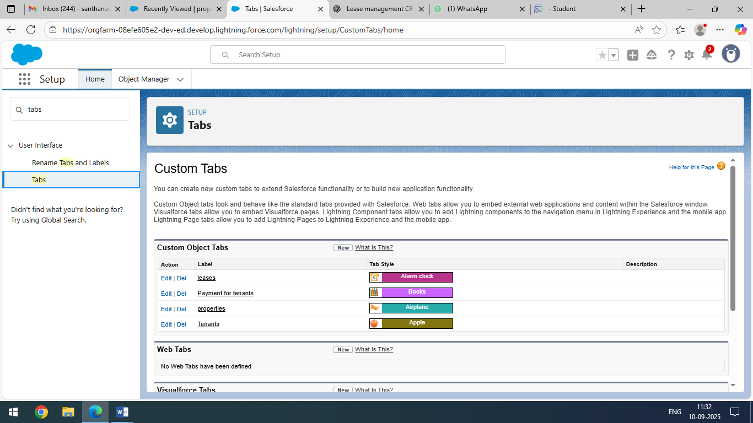

**The Lightning App:**

*To Create Lightning App For Lease Management.

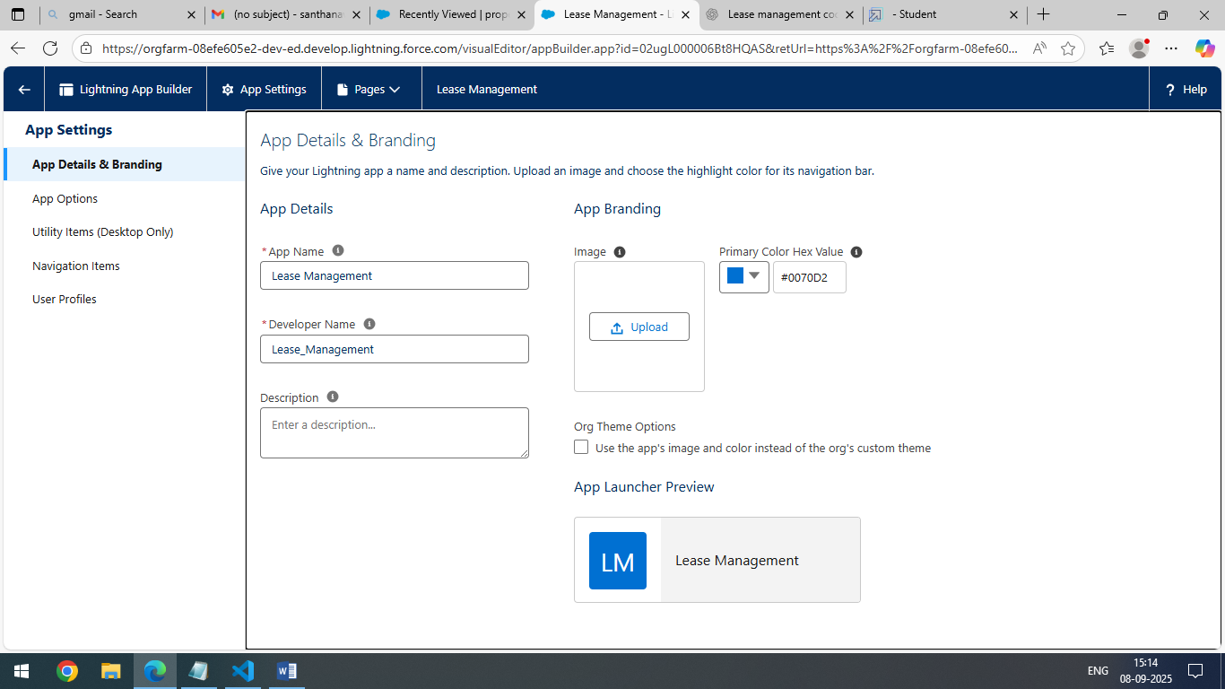

**Fields:**

* **Creation of fields.**

> Property Object.

> Tentant Object.

> Lease Obeject.

> Payment for Tenant Object.

> Lookup Fields Object.

> Each object includes necessary fields such as Start Date, End Date,

>Rent Amount, Status, etc.

### ****Validation Rule****

### *To create a validation rule to an lease object.

> Prevent entering a Lease End Date earlier than the Start Date.

### 

**Email Template:**

* **To create Email Template**.

**>**  Tenant Leaving.

**>**  Leave Approved.

**>**  Rejection For Leave.

**>** Monthly Pament.

> Successful Payment.

> Each object includes necessary fields such as Start Date, End Date,

> Rent Amount, Status, etc.

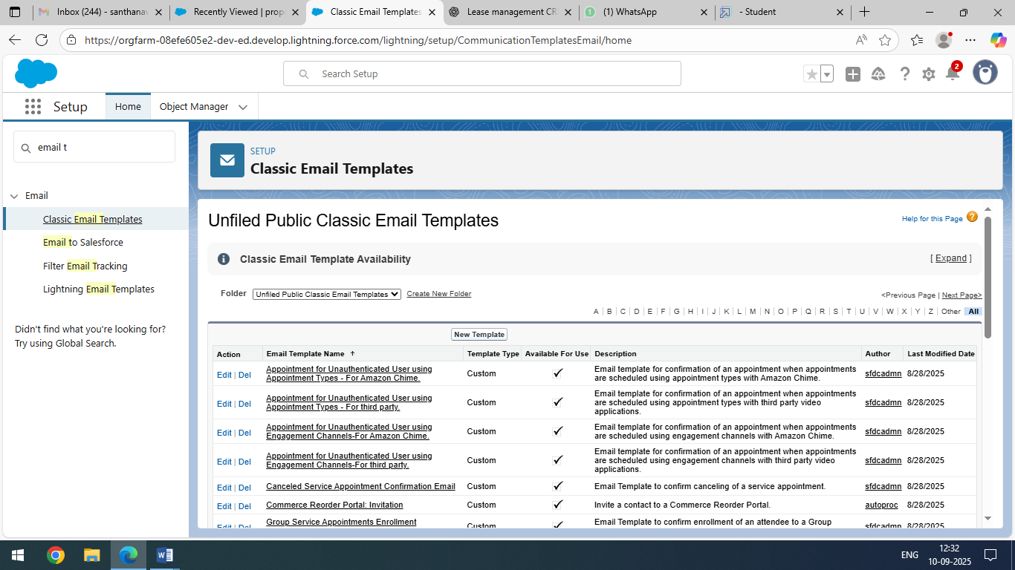 **Approval Processes:**

* To create approval processes for check for vacant.

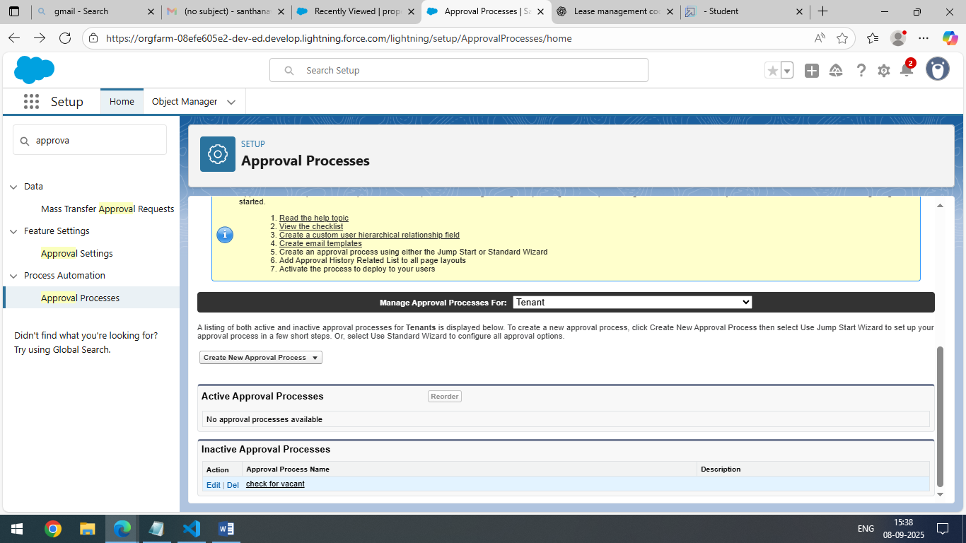

> Initial Submission Action.

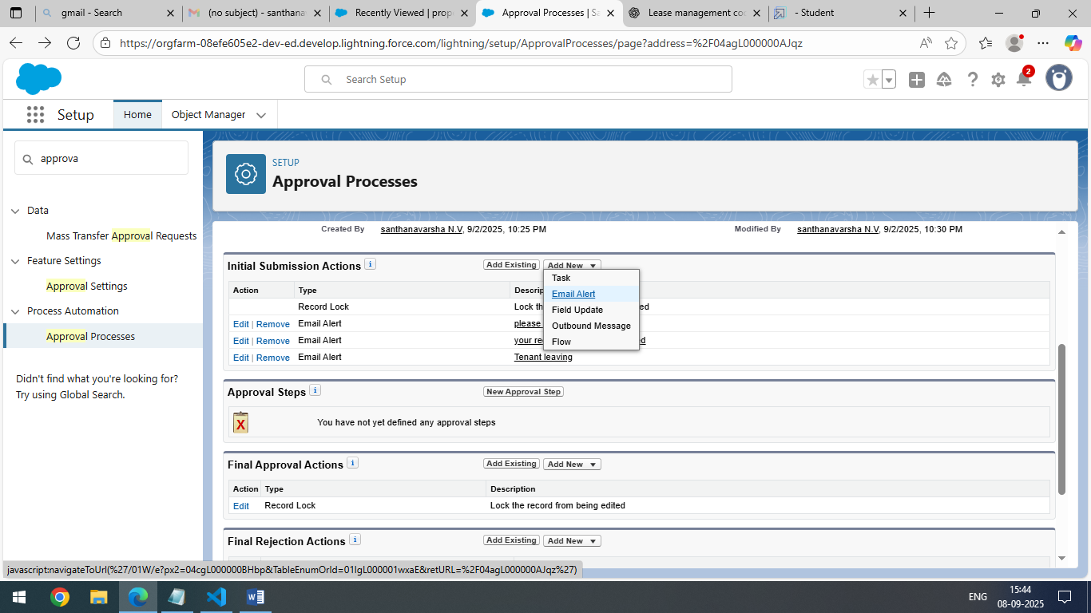

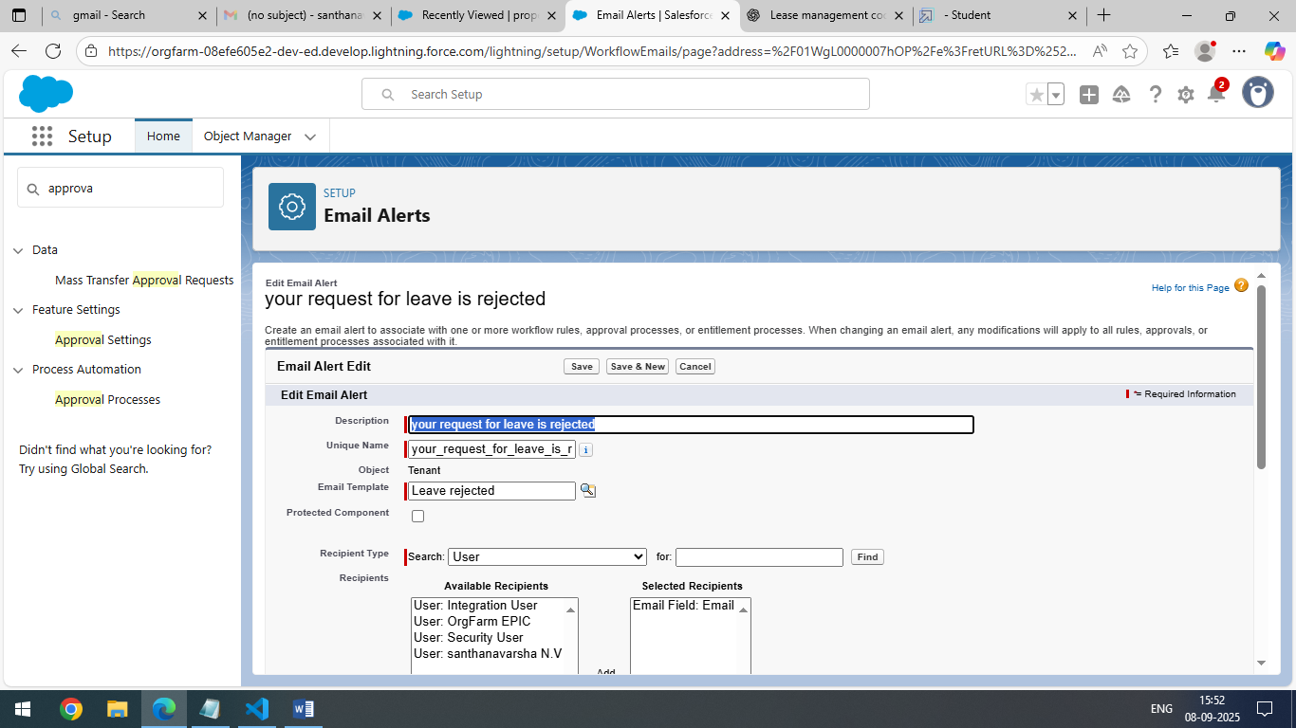 **>**Final Approval Action**.**

>Final Leave Rejection Action.

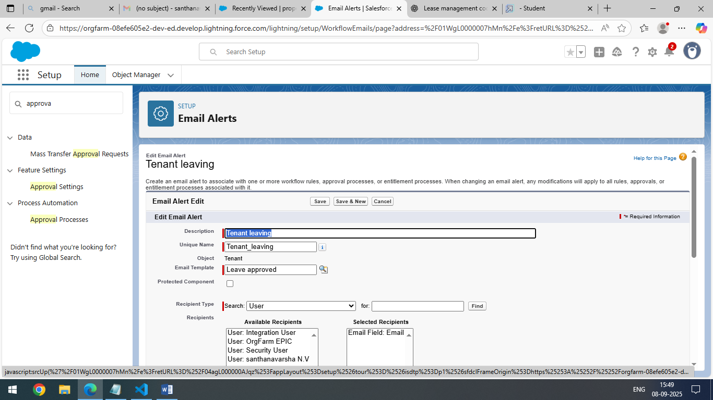

**Apex Tigger:**

*To create an apex tigger**.**

**>** Apex Trigger name as “test” & Object Name  “Tenant__c”.

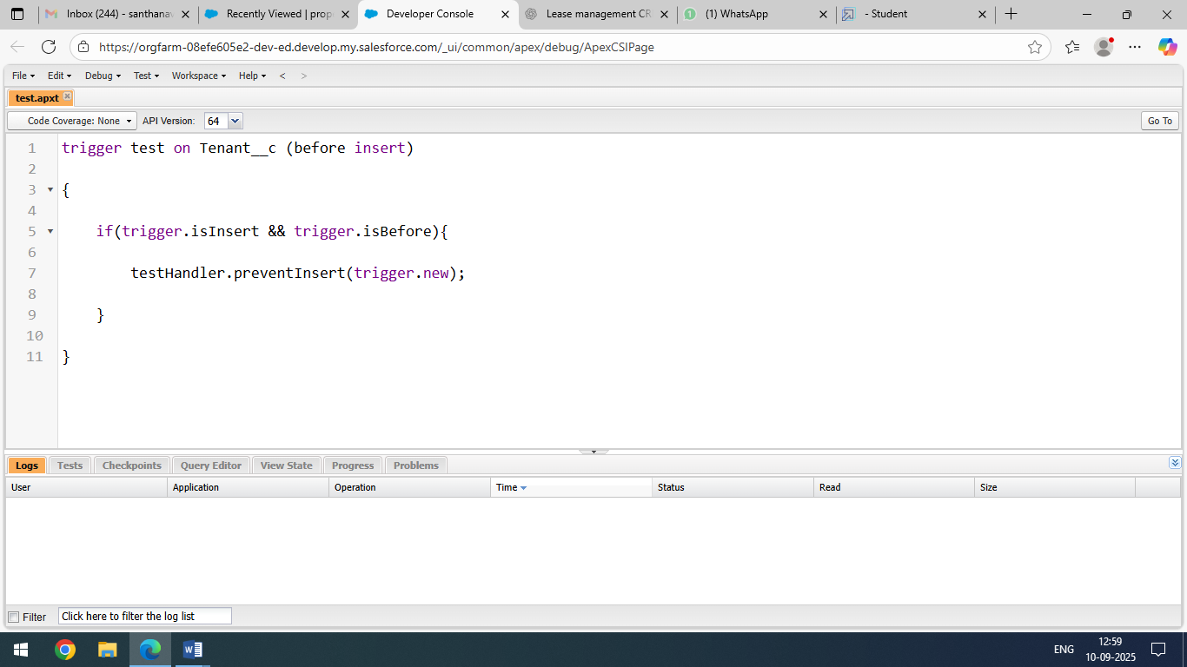

### 

*To Create Apex Handler Class.

> Apex Class Name As TestHandler.

.

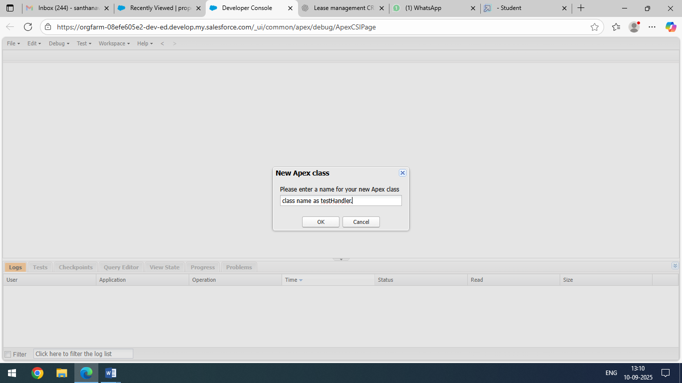

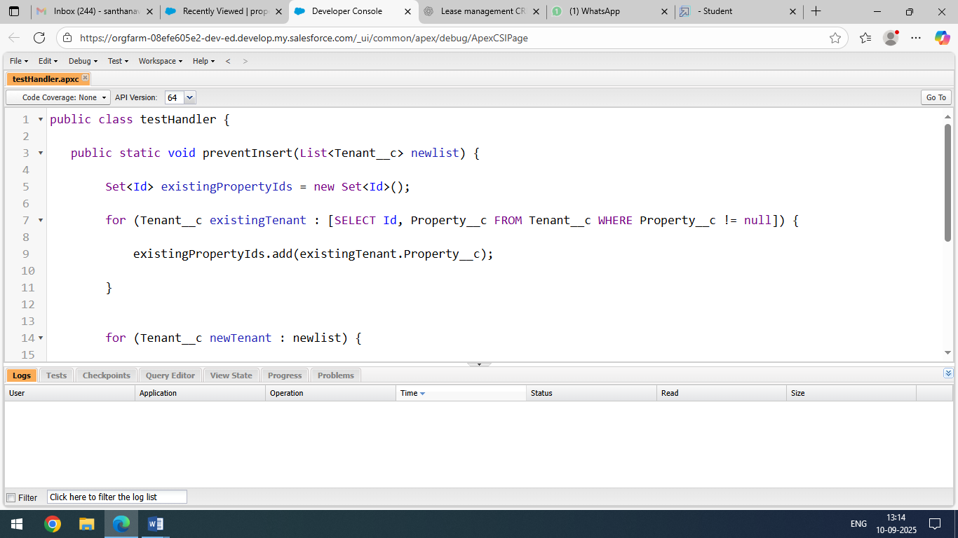

**Testing The Trigger:**

> Try To Create New Tenant With The Existing Property Then It Shows The Error.

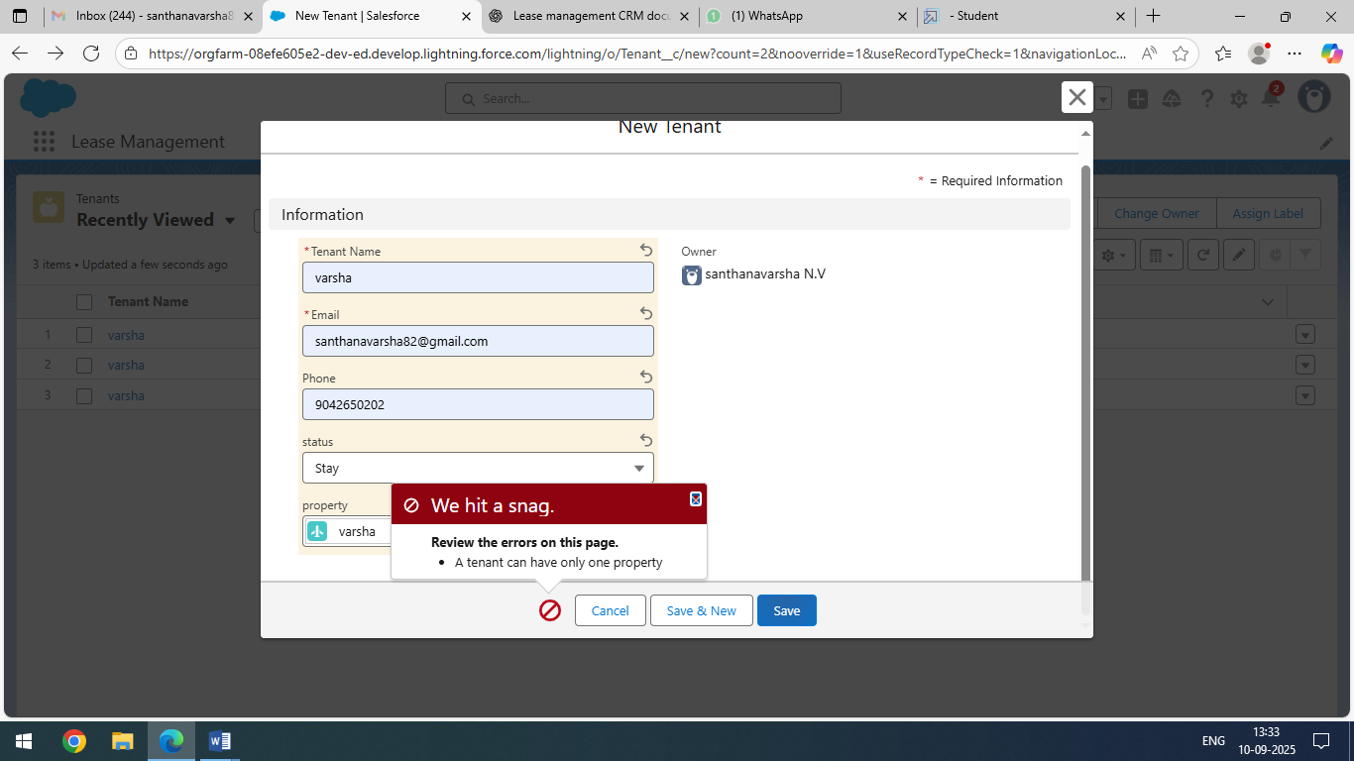

Automation Flows:

> Create Flow For Monthly Payment.

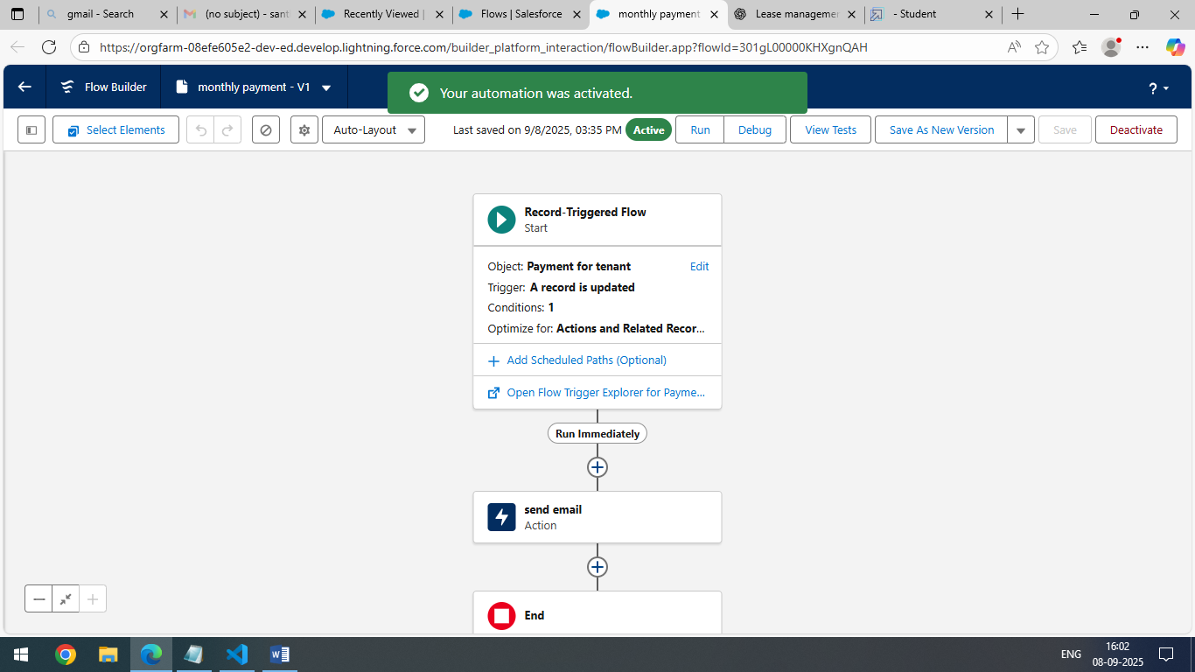

Schedule Class:

> Create Apex Class Name For MonthlyEmailScheduler.

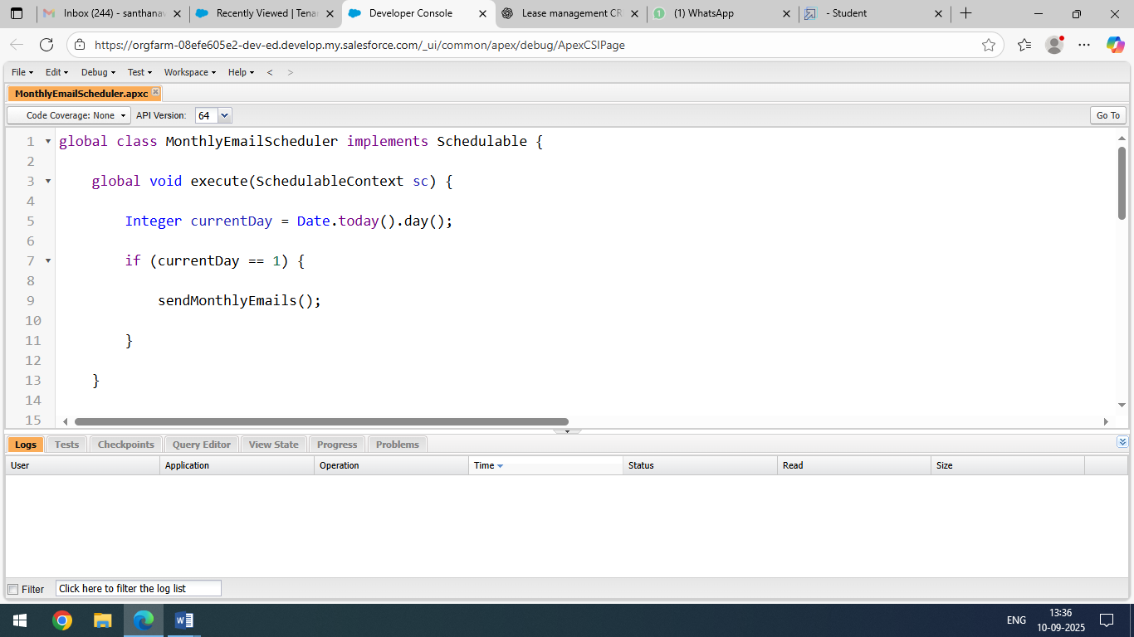

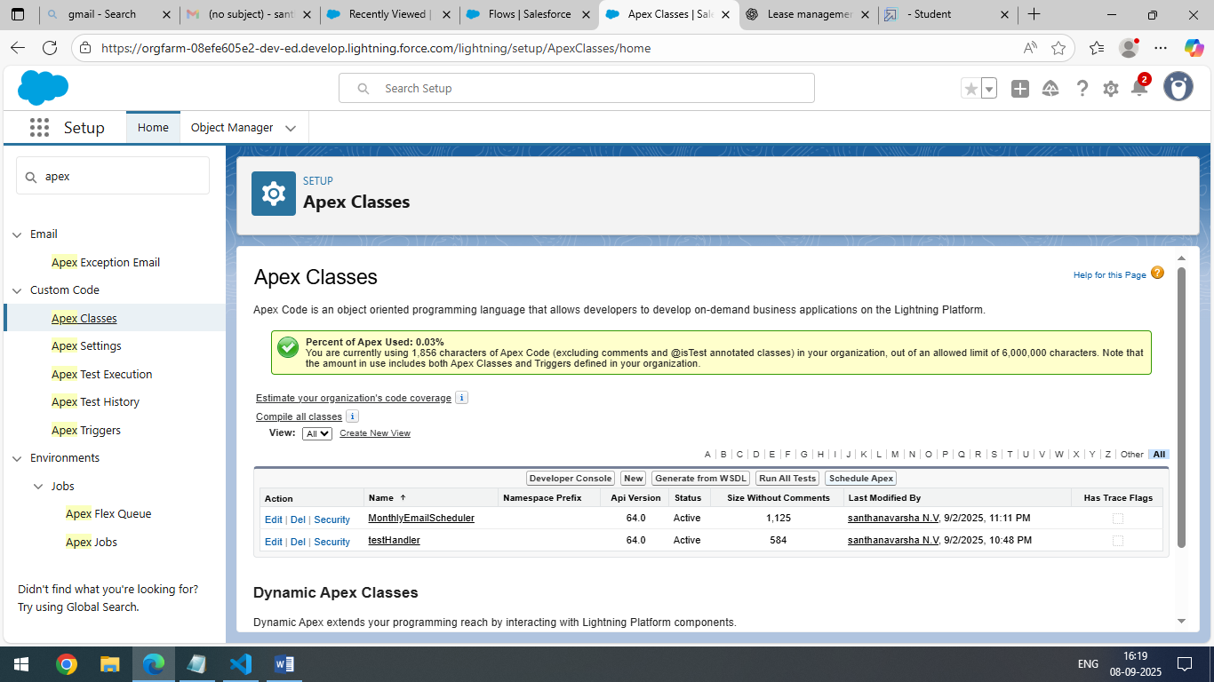

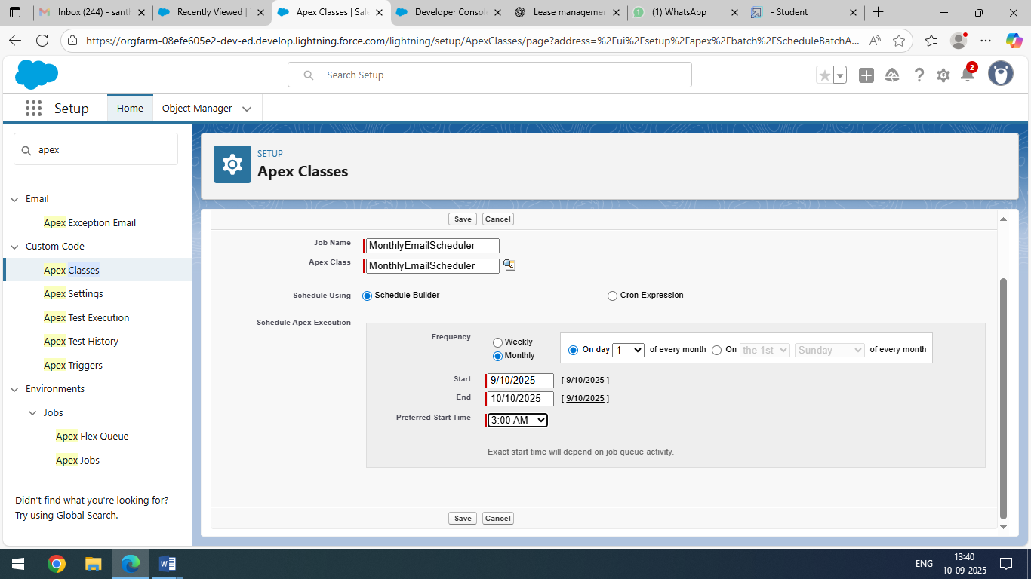

**Testing Approach**:  
 Testing performed on flows, reports, and dashboards by creating sample customer lease agreements, validating payments, and ensureng notifications trigger correctly.

**Future Enhancements**:

* Integration with online payment gateways.
* Chatbot for customer support.
* AI-based suggestions for renewal offers.

**Conculsion:**

The Lease Management CRM successfully digitizes and simplifies the leasing process, reducing manual work and ensuring accurate, timely management of tenant and property data. With automation and reporting features, it empowers businesses to improve tenant satisfaction, increase efficiency, and make data-driven decisions. Future enhancements will further strengthen the CRM with intelligent features, making it a scalable long-term solution.